#################################
OpenSSH v2
#################################
- PKI
- Transport-layer tunneling (encrypted TCP/UDP)
- supports passwordless logins
- supports port-forwarding (pseudo VPN)
- public key also known as "an identity"
~/.ssh ---contains keypairs and user-specific config files such as known_hosts

Package Groups (reported by rpm-qa | grep ssh)
openssh ----common to all packages
openssh-askpass ----for GUI - maintains credential information
openssh-server (sshd)
openssh-clients

openssh
/etc/ssh ---primary config area- with moduli
/usr/bin/ssh-keygen ----generate key pairs
/user/libexec/openssh/ssh-keysign
-- keygen and keysign have their own man pages
ssh-keygen -t rsa (t is type, can also be dsa)
--will create ~/.ssh/id_rsa and id_rsa.pub
-b 2048 option to specify a byte-size

askpass
/etc/profile.d/gnome-ssh-askpass.csh
/etc/profile.d/gnome-ssh-askpass.sh
/user/libexec/openssh/gnome-ssh-askpass
/user/libexec/openssh/ssh-askpass
-- maintains credential information so that user is not continually prompted

Clients:
[note --- v verbose also is debug]
/etc/ssh/ssh_config --- shared global config file for all clients
/etc/ssh/sshd_config --- shared global config file for SERVER

/usr/bin/scp --secure noninteractive copy
--- usage: scp sample.txt user@host:directory/ (":" indicates we are finished saying the target)
--- usage: scp user@host:directory/file.txt filecopy.txt
scp tcpdump.log.1 linuxcbtserv3:/temp
scp linuxcbtserv3:/temp/tcpdump.log.1 . ---copy from remote to local

/usr/bin/sftp --interactive FTP-like copy program --- usage: sftp user@host

/usr/bin/slogin

/usr/bin/ssh -- primary shell-based client -assigns a tty
--- usage: ssh user@host or ssh -l username 192.168.1.10
--- usage: ssh user@host "command" ----for one command line (no extended session)

/usr/bin/ssh-keygen ----generate key pairs
--- usage: ssh-keygen -t rsa (t is type, can also be dsa)
will create ~/.ssh/id_rsa and id_rsa.pub

/usr/bin/ssh-copy-id ---easy propagation of public and private key pairs to remote systems
--- usage: ssh-copy-id - ~/.ssh/id_rsa.pub username@servername.net
This will allow the user to login as username on servername.net without asked for passwd.
This will prompt us to locally accept the public key of servername.net and add to known_hosts and or authorized_keys.
ssh-copy-id -i .ssh/id_rsa.pub username@host

/etc/ssh/ssh_known_hosts --- systemwide known hosts file

/usr/bin/ssh-agent ---houses said credentials when communication with remote SSH servers so that user isn't constantly asked for passphrase. Needs to be the parent process:
ssh-agent bash --- starts bash as child process of ssh-agent
/usr/bin/ssh-add .ssh/id_rsa -----adds credentials into memory
/usr/bin/keyscan ---scan hosts for public keys, adds discovered public keys into ~/.ssh/known_hosts file
On client, run ssh-agent bash, then ssh-add ~/.ssh/id_rsa in order to not be prompted for passphrase

known_hosts contains IP address of remote servers, type of key (ssh-rsa) followed by public key per entry

Note: Security edition has a different method for password-less authentication. It's method is to copy the public key and place it in a file called /.ssh/authorized_keys on the other machine. That file also needs to be chmod 600 or ssh will complain about liberal permissions. This file should be chattr'd as immutable to disallow compromise.

A third method is to scp the keyfile to the other machine and cat the contents in:
scp ~/ssh/id_rsa.pub username@192.168.1.125:mykeyfile
mkdir .ssh
cat mykeyfile >> ~/.ssh/authorized_keys

/etc/ssh/ssh_config --- shared global config file for all clients
# Host *
# ForwardAgent no
# ForwardX11 no
# RhostsRSAAuthentication no
# RSAAuthentication no
…. etc options
-- All can be turned off or on at the cmd line
Cyphers used, identity file locations, port, version, escape character to kill session, tunneling enabled,
On the protocol line, be sure it doesn't list 1…. that is SSH v1 (old)
sshd_config additionally includes logging directives, restrictions on root, max tries to login attempts, login grace times
SET AUTHENTICATION: "PermitRootLogin no" to keep from logging in as root

--------------
ECDSA or RSA key fingerprints received and stored in .ssh/known_ hosts
ssh -p portnumber user@servername.domain.com
vim /etc/ssh/sshd_config ---> disable root login and change port number

First time login - client connection request. Server sends public key /etc/ssh/ssh_host.pub. Client asks before adding to .ssh/known_ hosts.

Private key - client ~/.ssh/id_rsa Send a public key (.pub) - is kept on server
ssh-keygen to make keys in home dir or elsewhere

ssh-copy-id server.domain.com to copy over your keys
RHEL7 copy-id allows for specifying ports. -i for identity file
ssh -p portnumber user@servername.domain.com
This should let you log in without asking for the passphrase.

scp -P [portnumber] filename.txt example.tester.com:~
Note: P capitalized since -p is preserve file info; don't forget destination directory.

-------------------------

Port forwarding (psudo VPNs)
- Exercise binds telnet to localhost, which is somewhat irrelevant. Edit /etc/xinet.d/telnet and add the bind= 127.0.0.1 line to only be accessible to loopback.
- local (127.0.0.1:23) -> SSH TUNNEL -> remote (127.0.0.1:23)
ssh -L 2323:127.0.0.1:23 192.168.87.4
- (since port is above 1024, you don't have to be root)
Instructs remote server's SSH daemon to bind loopback to port 23
This will work until you exit. Exiting the shell will kill the session.
To make a port on the remote system forward, rather than a local port, use -R

ssh -N -L 8888:ip.address.to.home:80 user@machine -------quick port tunneling
ssh -L 2525:192.168.87.1:25 192.168.87.1 --bind 2525 to 25- use mailer restricted to localhost through ssh tunnel
ssh -X user@ipaddress will allow you to use gui tools remotely

MD5SUM
/usr/bin/md5sum
md5sum filename - returns md5sum
md5sum filename* - get values on filename1 and filename2

Tunneling X Sessions through SSH
WS3 = server (has SSH daemon installed), WS1 = client

First configure client to accept connections from server. On WS1:
xhost +192.168.1.125 ------adds WS3 to the ACL

On WS3 tell xserver to send to other:
DISPLAY=192.168.1.108:0.0
export DISPLAY
edit /etc/ssh/sshd_config - ensure X11Forwarding = yes and uncommented

On WS1, to connect:
ssh -X -l username 192.168.1.125
(enter password)
Prompt will now indicate shell on WS3 and programs will run from there (such as gedit)

===========================

- /etc/securtty lists trusted TTYs that can run root. SSH bypasses this

Restrict SSH root access:
/etc/ssh/sshd_config
PermitRootLogin=no
service sshd reload
- this won't let you log in as root, but su still works to get root.
More on SSH - in Nessus section, it is mentioned to change the line allowing old SSH1 by changing "Protocol 2,1" default to "Protocol 2"

On banner files and hiding detections
/etc/sshd.config contains directive to banner file with Banner directive. you can point it to the /etc/issue or another file.

===========================

Vugt SSH stuff- RHCE

client side - ssh-keygen makes:
~.ssh/id_rsa -- private, might say dsa instead
~.ssh/id_rsa.pub --public, regardless of enc type used, will always end in ".pub"

Using ssh-copy-id, /id_rsa.pub is copied to the server in (your home directory) ~/.ssh/authorized_keys
(it concatenates the authorized_keys file)

Afterward, since a token signed by the private key is sent to the server, no passwords are sent- the server simply determines whether or not it can decrypt with the public key. The passphrase is asked when using the private key (such as logging into the server with SSH). In such a case attacker would need to compromise both the passphrase and the private key.

Fact: believe it or not, you could still have a private key without a passphrase to use it. If someone stole the private key, at least they would still need the passphrase

ssh-keygen -t dsa --(type uses stronger DSA instead of default RSA; asks for passphrase)
ssh-copy-id server2 (asks for server2's password)
ssh server2
"Enter the passphrase for key '~/sshd/id_dsa"
- note again- this is looking at the key in users local home directory

So, what if you don't want to be asked by server2 for a passphrase at this point?
This will work for only the current shell, and as long as it is not terminated or restarted
On Server1 (your home), type:
ssh-agent /bin/bash
ssh-add (you are asked for the private key's passphrase)
This temporarily caches your passphrase.

/etc/ssh/sshd_config
Turn off password authentication to only allow key-based authentication
(the file says "to disable tunneled clear text passwords" but it does the trick)
PasswordAuthentication = no <---- change this from yes to no
Many people choose to leave it on because you have to MUST have a key or be locked out.

(PubkeyAuthentication might need to be uncommented, ChallengeResponseAuthentication also asks for passwords and should be commented out or turned off. Some even suggest setting UsePAM to 'no' as well, but that is probably overkill)

It also alleviates any worries about someone trying to brute force password attempts: "If you'll always be able to log in to your computer with an SSH key, you should disable password authentication altogether. (By doing so,) it will only be possible to connect from computers you have specifically approved. This massively improves your security, but makes it impossible for you to connect to your own computer from a friend's PC without pre-approving the PC, or from your own laptop when you accidentally delete your key."

SSH options
In ssh_config
Port: 22 - on the internet you need to change this- scanners will find it and bombard it
ListenAddress: change this to a subnet - or at least a host... you can have multiple lines with this value (there are two commented out that are provided.
ListenFamily lets you specify IPv4 or 6

PermitRootLogin. Uncomment this and say "no"
AllowUsers - lets you specify usernames (don't use common names- to avoid brute force)

GSSAPI and Kerberos - turn off unless needed
X11 forwarding - if you think it's insecure turn it off... actually just turn it off. :)

TCPKeepAlive- yes or no. T weak it with ClientAliveInterval and ClientAliveCountMax - measured in minutes

SELinux problems:
It doesn't start because it doesn't like the port.
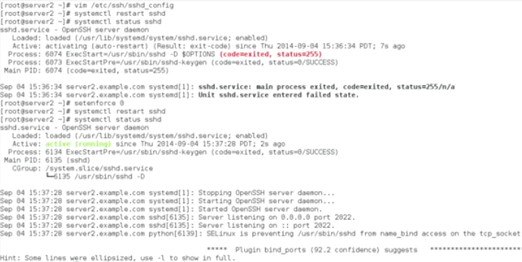
Check the AVC messages in /var/log/audit/audit.log that report SELinux entries
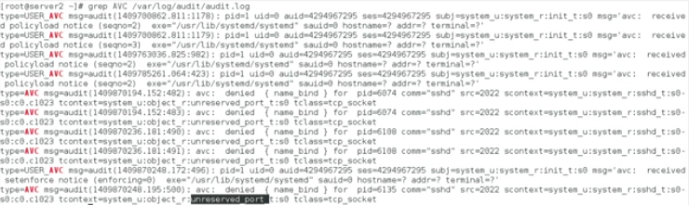

semanage port -l (listening ports) shows that the port type for port 22 and sshd is ssh_port_t
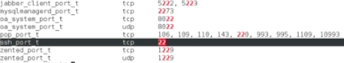

Checking the semanage manpage, it lists related pages, and semanage-port.
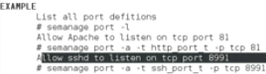

[root@server2 ~]# semanage port -a -t ssh_port_t -p tcp 2022
You don't have to run restorecon or anything
[root@server2 ~]# semanage port -l |grep ssh
ssh_port_t tcp 2022,22
systemctl restart sshd

SSH Client Options
Put the config file in ~/.ssh/config for a specific user and/or /etc/skel/.ssh/config to be default user options

In /etc/ssh/ssh_config on the client
- there is also an Forward X11 yes/no option
- ssh -X (ip address or host) - also works for that session
Port
GSSAPI and Kerberos settings are also present

SSH Tunneling
ssh - fNL 4444:server.rhcertification.com:80 root@server2.example.com
f and N make it run as a background process instead of opening an ssh session
L is "local port forwarding" - make a local port available and forward it somewhere else
We are forwarding the local port 4444 to server.rhcertification.com:80, and to forward it, using root@server2.example.com

Make 4444 available, and make everything going to local port 4444 will go to myserver.rhcertification.com and in order to do that, we are making an SSH connection to server2
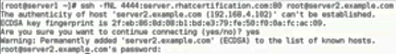
We then do "elinks http://localhost:4444" and it opens the website at server.rhcertification.com

ssh - fNL 5555:localhost:80 root@server2.example.com
This goes out 5555 to server2.example.com, aand tries to get to localhost:80
So "elinks http://localhost:5555" resolves and "localhost" on that port is actually localhost on server2
Obviously, this is still local port forwarding.

Remote port forwarding:
ssh p 2022 -r 80:localhost:8088 sander@lab.sandervught.nl
(He had to add port 2022 as lab.sander... was running a custom port number for ssh)

lsof -i -n | grep ssh
-i "listing of files any of whose Internet address matches the address. If no address is specified, this option selects the listing of all Internet and x.25 (HP-UX) network files."
-n "inhibits the conversion of network numbers to host names for network files... make lsof run faster. It is also useful when host name lookup is not working properly."
netstat -tulpen | grep ssh shows shh listening on ports 4444 and 5555
